**Objective:**

This workshop is intended for sharing fundamental aspects of E2E Testing using Cypress tool. This workshop will give hands on experience to the participants to start implementing Cypress. Some basic to intermediate topics of Cypress will be covered in this workshop.

At the end of the workshop, a sample reference project will be shared with the audience.

**Duration: 120 mins**

**Target Audience:** Anyone having knowledge of Programming with no prior knowledge of Cypress.

**Takeaway:** Hands-on knowledge of Cypress

**Cypress Workshop**

1. Introduction to Cypress (T) (5 mins)

* What is Cypress
* Architecture
* Benefits
* Browsers supported as of now

1. Installation of Cypress (T) (5 mins)

* Command to install Cypress
* Folder structure
* Cypress.json file (Config file)

1. Getting started with Cypress(T+H) (25 mins)

* Mocha Framework
* Cypress commands
* Locators (css-selectors)
* Assertions(Chai and Built In)
* Test Execution (Command Line)
* Configuring scripts via package.json

1. Hands On (15 mins)
2. Q&A (10 mins)
3. Break (5 mins)
4. Fixtures(T) (2 mins)
5. Page Object Model (T) (18 mins)
6. Hands On (15 mins)
7. Advanced Topics (T) (10 mins)

* Mochawesome Reports
* Adding plugins
* CI-CD (Jenkins)
* Promise Handling (its JS feature)
* API Testing (basic)

1. Challenges
2. Q&A session (5 mins)

**Prerequisite**

**Installation for MAC machines**

1. **Install Node.js**

* Visit <https://nodejs.org/en/download/> and install node.js. Click on Windows Installer(.msi)(64 bit) OR Windows Installer(.msi)(32 bit) depending on your OS.
* In case node.js is already installed upgrade nodeJs to >8

* Set the NODE path in your system variables

Goto location where you installed nodejs (default= C:/Program Files/nodejs) and copy the path

* Now, right click on “My Computer”, click on properties and then on “Advanced system settings”

* On system variables, click on New

In ‘New System Variable’ pop up enter,   
Variable name as “NODE_HOME”

Variable value as path to nodejs (Default=“C:\Program Files\nodejs”)

* Click “OK” on New system variable, Environment variable and System Properties
* Verify if node is properly installed by going to CommandPrompt and type

node --version

You must be able to see installed version of node

* Download Chrome and Edge if you don’t already have

Chrome= <https://www.google.com/chrome/>

Edge= <https://www.microsoft.com/en-us/edge>

1. **Create Workspace**   
   Create an empty folder(this will work as your workspace) (eg C:/Documents/CypressAutomation)

1. **Install Editor**

<https://code.visualstudio.com/download> and Open it

1. Open the folder(CypressAutomation) you created in step 2 from your Editor(VSCode)

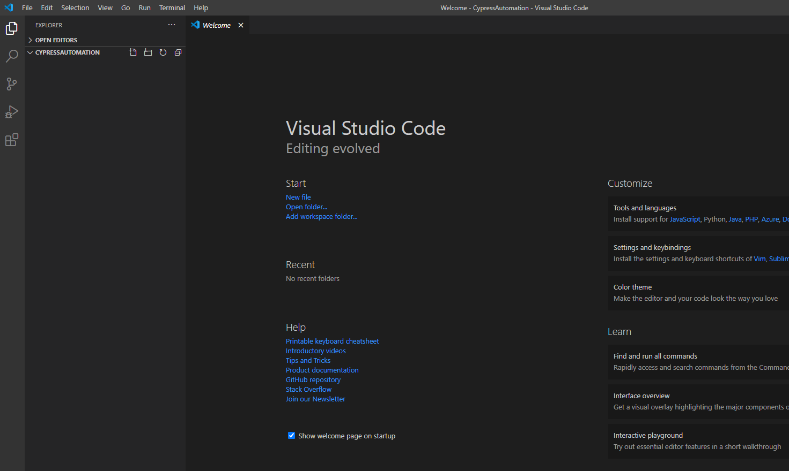

1. **Generate package.json file** for your project

* Package.json is just like your pom.xml file in selenium which contains all the libraries we will be using
* In your Editor open terminal and type

npm init

Keep pressing <enter> till it installs

Expand you folder CypressAutomation to see if package.json has appeared

1. **Install Cypress**It will install cypress and will also save it as dev dependency in your package.json  
   Now in your Editor’s terminal type   
   npm install cypress - -save-dev

Make sure you get a node_modules folder inside your workspace

1. **Open Cypress**   
   Type   
   npx cypress open  
   in your Editor’s terminal   
   A screenshot of a computer screen

   Description automatically generated

Click OK and close the window

And installation is Done!

Make sure you get the folder structure inside the cypress folder – Fixtures, Integration, plugins, support as in below screenshot

1. Write a small test and verify if everything is working fine

Create a folder inside integration folder and name it as ‘tests’

* Now create a file inside the ‘tests’ folder, name the file as ‘google.js’   
  Paste this code inside the file google.js   
  ///<reference types="Cypress"/>

describe("Verify google", function () {

it("Verify URL of google", function () {

cy.visit("https://www.google.com/")

cy.url().should("contain", "google")

})

})  
And execute the code typing below command in Editor’s terminal

npx cypress open

On the interface click on google.js

1. Make sure your code executes successfully   
   Graphical user interface, application

   Description automatically generated
2. You can start reading some basic commands of Cypress

<https://cheatography.com/aiqbal/cheat-sheets/cypress-io/>